Lab No. 10

Intel x87 Floating Point Unit

Task no 01:
Write the floating-point double precision version of dot product code, provided in last lab.

Program:

.686
.MODEL FLAT, C
.DATA
a REAL10 10.0, 20.0, 30.0, 40.0, 50.0, 60.0, 70.0, 80.0
b REAL10 100.0, 200.0, 300.0, 400.0, 500.0, 600.0, 700.0, -800.0
N DWORD 8
sum REAL10 0.0
.CODE
Main PROC
fldz
mov esi, OFFSET a
mov edi, OFFSET b
mov ecx, DWORD PTR N
DotLoop:
fld QWORD PTR [esi]
fmul QWORD PTR [edi]
add esi, 8
add edi, 8
dec ecx
jnz DotLoop
fstp QWORD PTR sum ; store final sum
ret
Main ENDP
END Main

Output: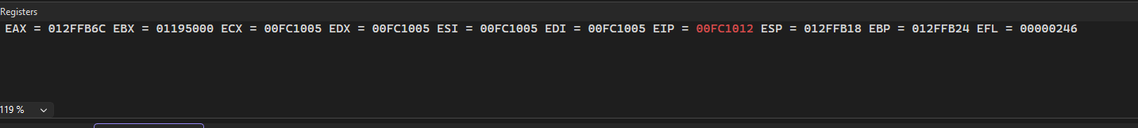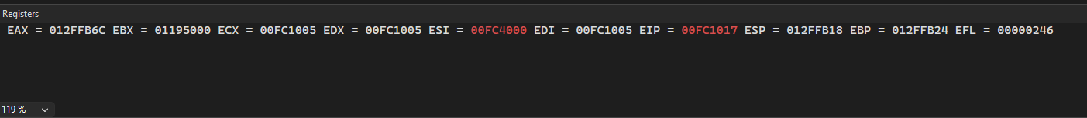
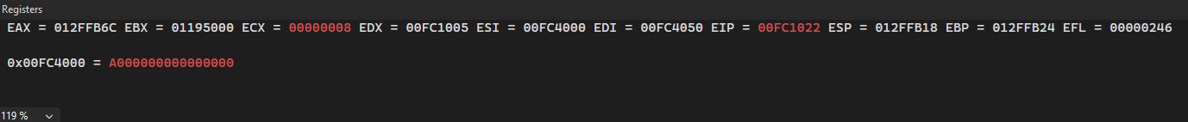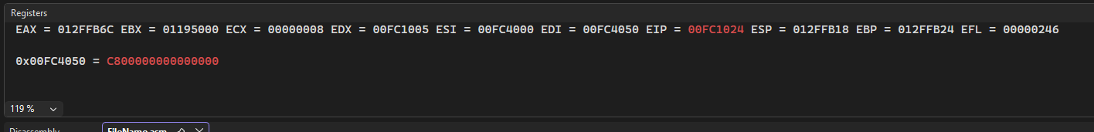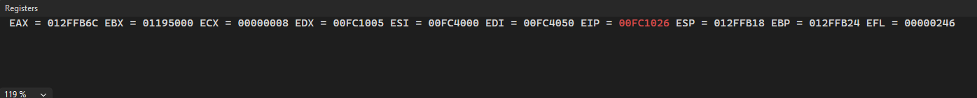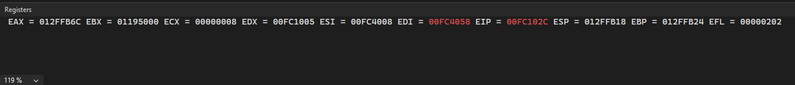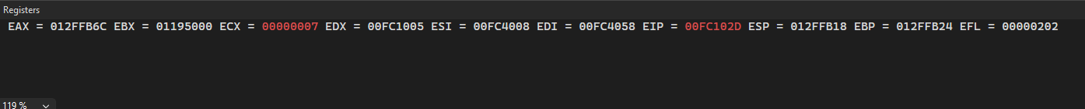
Task no :02
- Write, build, and debug the C with inline-assembly dot product floating point code.
Program:
#include <stdio.h>

int main() {
double A[3] = {5.6, 3.8, 2.0};
double B[3] = {2.4, 10.3, 4.0};
double result = 0.0;

__asm {
; A[0] * B[0]
fld QWORD PTR A[0]
fmul QWORD PTR B[0]

; A[1] * B[1]
fld QWORD PTR A[1]
fmul QWORD PTR B[1]
faddp st(1), st(0)

; A[2] * B[2]
fld QWORD PTR A[2]
fmul QWORD PTR B[2]
faddp st(1), st(0)

; store result
fstp QWORD PTR result
}

printf("Dot Product = %lf\n", result);
return 0;
}
Output:
